During the final mounting of the board, make the coding as shown at the arrow.in the drawing below:

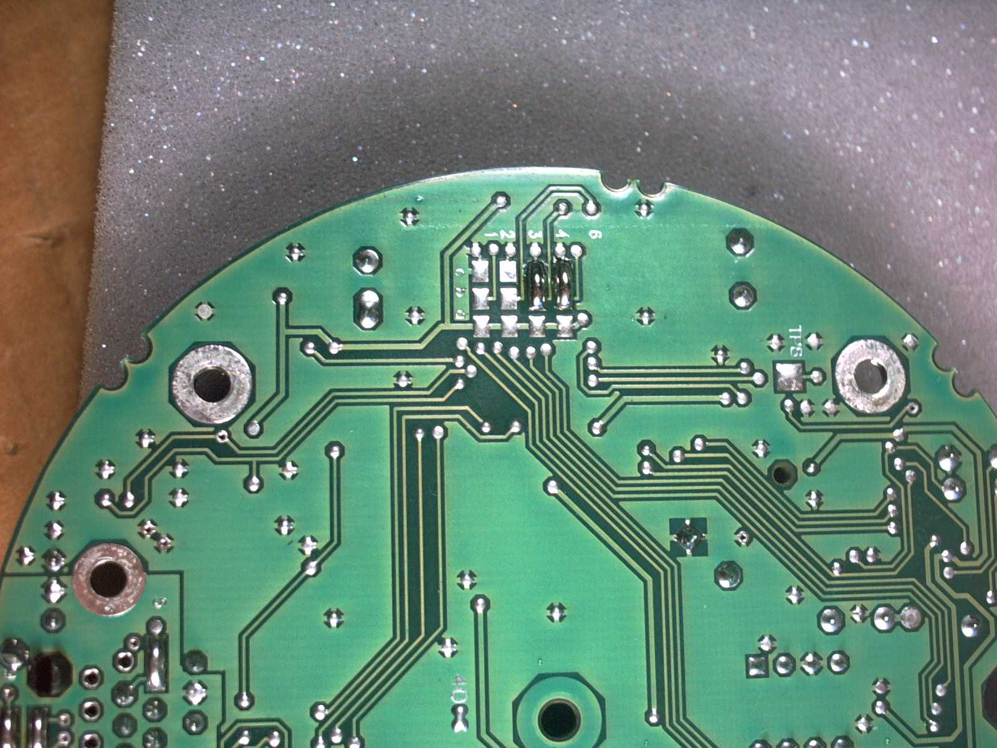

(At power up the Baud rate could be read as 19.200. This could give start problem for the system).

